**Grants Award Memo Workflow Administrator’s Guide**



**Tom Molskow**

**Senior SharePoint Architect**

**Grants Award Memo Workflow Administrator’s Guide**

Contents

1. High Level Process Overview: 3

2. Roles: 3

3. Technology Stack: 3

4. Solution Components: 3

5. Grants Award Letter Workflow: 6

6. Grants Award Letter Task Workflow: 27

Appendix A – User Guide 39

Appendix B – User Training 40

1. High Level Process Overview:

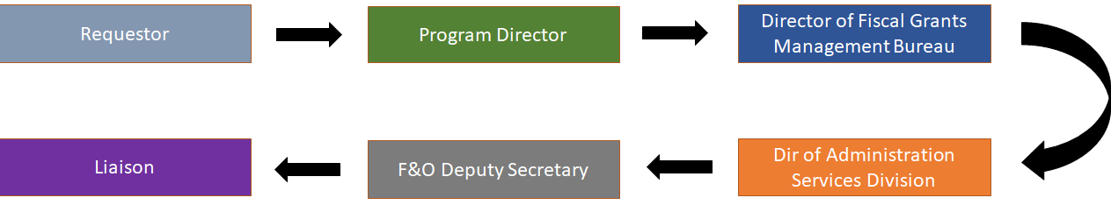

## Roles:

1. Requestor – The Individual Who Submits the Award
2. Liaison – The Individual Who Facilitates Getting and Verifying the Award Information
3. Program Director – 1st Reviewer (Reviews, Approves\Declines, Signs)
4. Director of Fiscal Grants Management Bureau – 2nd Reviewer (Reviews, Approves\Declines, Signs)
5. Director of Administrative Services Division – 3rd Reviewer (Reviews, Approves\Declines, Signs)
6. F&O Deputy Secretary – 4th Reviewer (Reviews, Approves\Declines, Signs)
7. Liaison – 5th Reviewer (Reviews, Approves\Declines, Signs)

## Technology Stack:

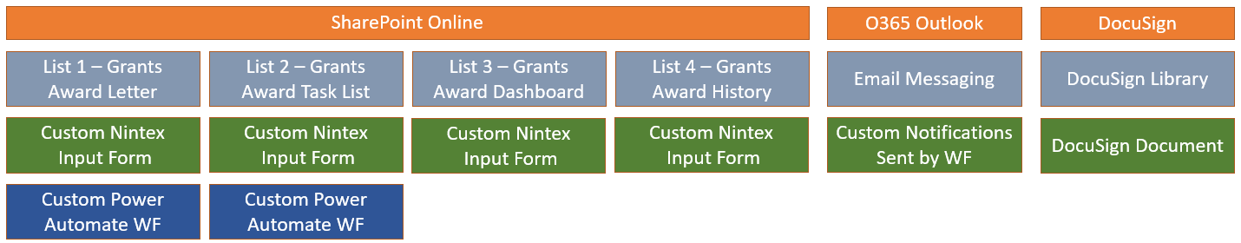

## Solution Components:

1. SharePoint Online:
   * SharePoint Online List 1 – Grants Award Letter:
     + Custom List
       - Custom Award Metadata
       - Used to Track the Grant Awards Letter Process per Request
       - Fields:
         * ID | Integer
         * Name of the Award (Title)| Single Line Text
         * Award Letter Link (URL, Alternative Text) | Hyperlink
         * Requestor – Name | Person or Group
         * Program Director – Name | Person or Group
         * Director of Fiscal Grants MB – Name | Person or Group
         * Dir of Administration Services Division – Name | Person or Group
         * F&O Deputy Secretary – Name | Person or Group
         * Liaison – Name | Person or Group
         * Description | Multiple Lines of Text
         * Status | Choice
         * Run WF | Choice
         * Attachments | Choice
         * DB ID | Single Line of Text
     + Custom Nintex Input Form
       - Custom Rule Logic – The "Run WF" Field Cannot be Set to "Yes" if Any Other Field is Empty
       - Front End to Custom Power Automate Workflow
       - Fields:
         * Form Title | SPO Field Title | Field Type | Locked Status
         * Grant Award Memo Title | Title | Single Line of Text | Unlocked
         * Award Letter Link | Link to Award Letter | Single Line of Text | Unlocked
         * Requestor | Requestor Name | People Picker | Unlocked
         * Program Director | Program Director – Name | People Picker | Unlocked
         * Director of Fiscal Grants MB | Director of Fiscal Grants MB – Name | People Picker | Unlocked
         * Dir of Administration Services Division | Dir of Administration Services Division – Name | People Picker | Unlocked
         * F&O Deputy Secretary | F&O Deputy Secretary – Name | People Picker | Unlocked
         * Description | Description | People Picker | Unlocked
         * Current Process Participant | Status | People Picker | Unlocked
         * Start the Grant Award Memo Workflow | Run WF | Boolean | Unlocked
     + Custom Power Automate Workflow
       - Automates Grants Award Memo Process
       - Creates Process Task Item
       - Automates Award Memo Item Security
       - Sends Tasks Notifications
       - Creates Process Dashboard Item
       - Creates Process History Item
   * SharePoint Online List 2 – Grants Award Task List:
     + Task Content Type
       - Task Metadata
       - Used to Track Individual Task Activity per Request
       - Fields:
         * ID | Integer
         * Title | Single Line of Text
         * Task Status | Choice
         * Assigned To | Person or Group
         * Completion Status | Choice
         * Start Date | Date and Time
         * Body | Multiple Lines of Text
         * Ref ID | Single Line of Text
         * Ref Title | Single Line of Text
         * DB ID | Single Line of Text
         * Due Date | Date and Time | *Not Used*
         * Predecessors | Lookup | *Not Used*
         * Priority | Choice | *Not Used*
         * Related Items | Related Items | *Not Used*
     + Custom Nintex Input Form
       - Front End to Custom Power Automate Workflow
       - Fields:
         * Form Title | SPO Field Title | Field Type | Locked Status
         * Grant Award Memo Title | Task Name | Single Line of Text | Locked
         * Process Role | Task Status | Drop Down List | Locked
         * Task Assigned To | Assigned To | People Picker | Locked
         * Task Completion Status | Completion Status | Drop Down List | Unlocked
         * Task Start Date | Start Date | Date | Locked
         * Task Instructions | Body | Multi-Line | Locked
     + Custom Power Automate Workflow
       - Updates Grants Award Letter Item Status
       - Creates Process History Item
       - Sets a 3 Business Day Reminder Date
       - At the Business Reminder Date Sends an Email to the Current Participant
   * SharePoint Online List 3 – Grants Award Dashboard:
     + Dashboard Content Type
       - Custom Dashboard Metadata
       - Used to Provide a High-Level View of All Process Requests
       - Fields:
         * ID | Integer
         * Title | Single Line of Text
         * Workflow Step | Choice
         * Current Participant | Person or Group
         * Award Letter Link | Hyperlink or Picture
         * Award Letter ID | Single Line of Text
         * Task Status | Choice
         * Task Date | Date and Time
         * Task ID | Single Line of Text
         * Current Phase | Single Line of Text
     + Custom Nintex Input Form
       - Fields:
         * Form Title | SPO Field Title | Field Type | Locked Status
         * Title | Title | Single Line of Text | Unlocked
         * Workflow Step | Workflow Step | Drop Down List | Unlocked
         * Current Participant | Current Participant | People Picker | Unlocked
         * Award Letter ID | Award Letter ID | Single Line of Text | Unlocked
         * Task Status | Task Status | Drop Down List | Unlocked
         * Task Date | Task Date | Date | Unlocked
         * Task ID | Task ID | Single Line of Text | Unlocked
         * Current Phase | Current Phase | Single Line of Text | Unlocked
   * SharePoint Online List 4 – Grants Award History:
     + History Content Type
       - Custom History Metadata
       - Used to Provide a History of All Requests Activities
       - Fields:
         * ID | Integer
         * Title | Single Line of Text
         * DTG | Date and Time
         * Task ID | Single Line of Text
         * List Name | Single Line of Text
         * Action Type | Choice
         * Action Participant | Person or Group
         * Additional Log Details | Multiple Lines of Text
         * Action Role | Choice
         * DB ID | Single Line of Text
         * % Complete | Number | *Not Used*
         * Related Items | Related Items | *Not Used*
     + Custom Nintex Input Form
       - Fields:
         * Form Title | SPO Field Title | Field Type | Locked Status
         * Title | Title | Single Line of Text | Unlocked
         * Date/Time | Date/Time | Date | Unlocked
         * Transaction Number | Transaction Number | Single Line of Text | Unlocked
         * List Name | List Name | Single Line of Text | Unlocked
         * Action Type | Action Type | Drop Down List | Unlocked
         * Action participant | Action participant | People Picker | Unlocked
         * Additional Log Details | Additional Log Details | Multi-Line | Unlocked
         * Action Role | Action Role | Drop Down List | Unlocked
2. O365 Exchange:
   * Email Messaging: Custom Task notifications sent from Power Automate workflows
3. DocuSign:
   * DocuSign Document
     + Award Letters
     + Request Documents

## Grants Award Letter Workflow:

* 1. Trigger:
     1. When an item is created or modified
     2. Site – IDEAB Site
     3. List – Grants Award Letter List
     4. Screen Shot

* 1. Condition
     1. If Statement
     2. If “Run WF” field value is equal to “Yes”
     3. Screen shot

* 1. Switch Statement
     1. On “Status Value”
     2. Screen shot

* 1. Case Statements “If Yes”:
     1. **Program Director**
        1. Create a Grants Award Task for the Program Director:

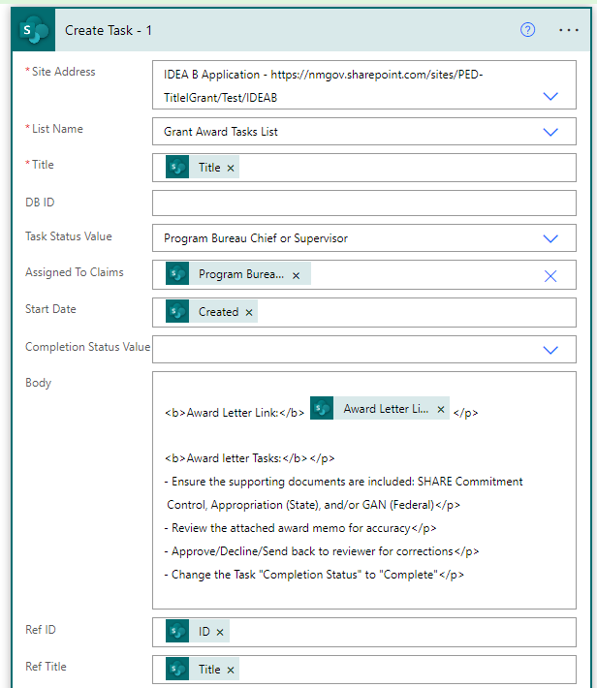

* + - 1. Send a task email to the Program Director:

* + - 1. Create a Dashboard Item to track this Grants Award Memo request:

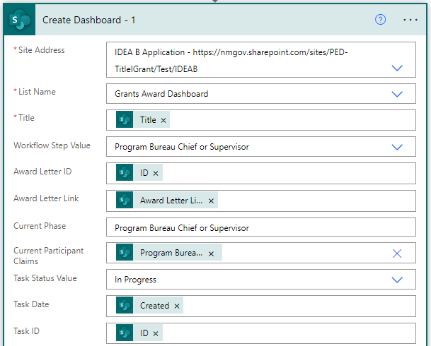

* + - 1. Update Grants Award Letter DB ID (Dashboard ID) field proving the ID from the newly created Grants Award Dashboard list item.

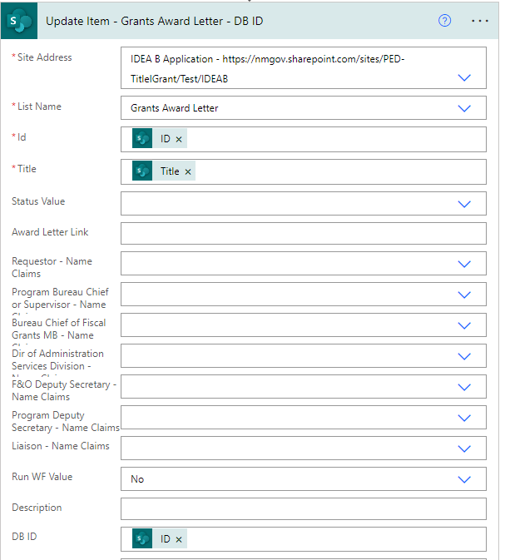

* + - 1. Update Item – Grants Award Task List – DB ID

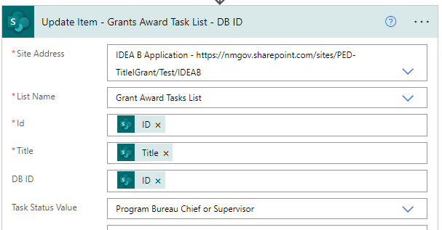

* + - 1. Create History Item – 1

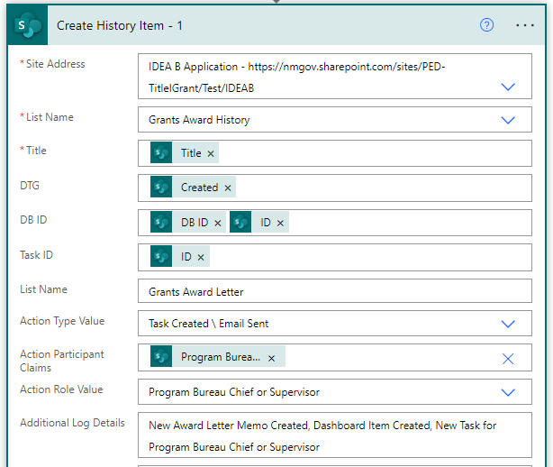

* + - 1. Break Inheritance

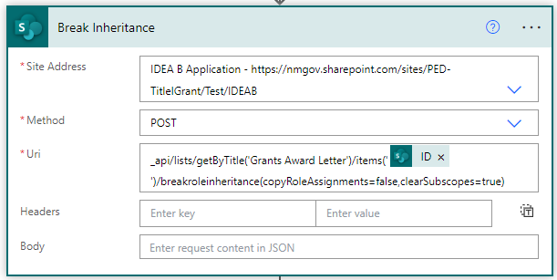

* + - 1. Stop Sharing Item – Grants Award Letter – Site Owner Keeps FC

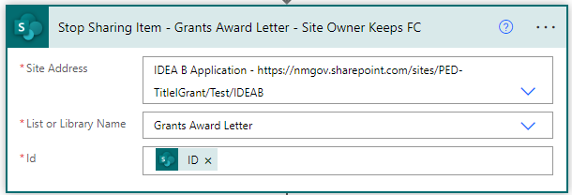

* + - 1. Grant Access – Requestor – 1

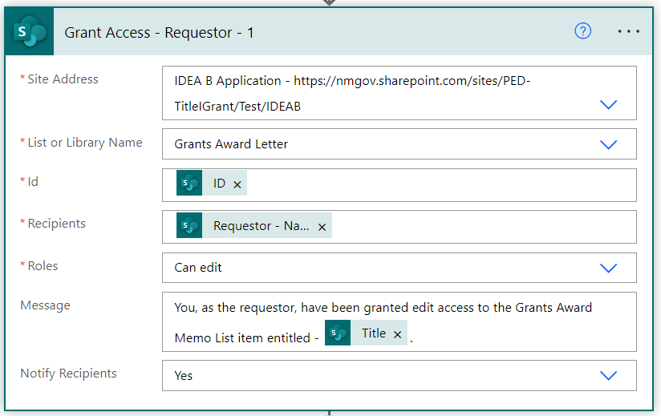

* + - 1. Grant Permissions – Program Director

* + - 1. Terminate – 1

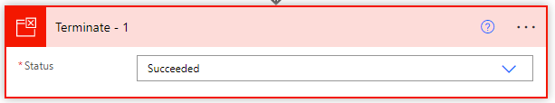

* + 1. **Director of Fiscal Grants Management Bureau**
       1. Create Task – 2

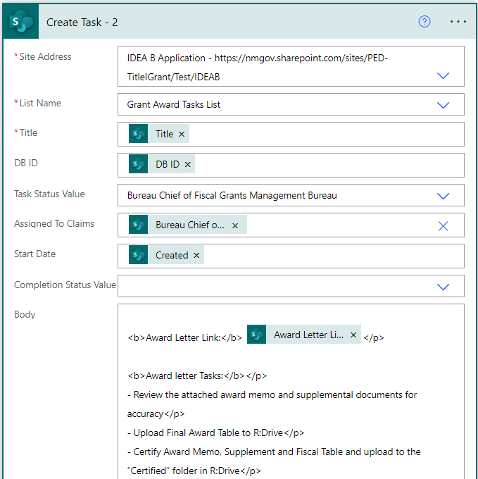

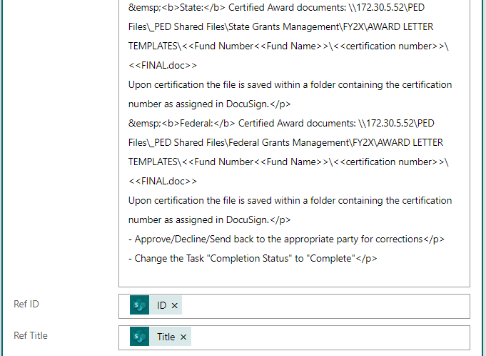

* + - 1. Send an Email – 2

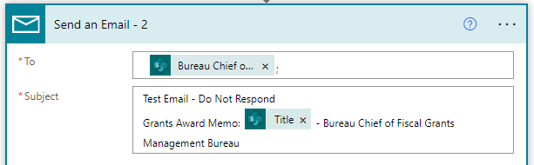

* + - 1. Update Dashboard – 2

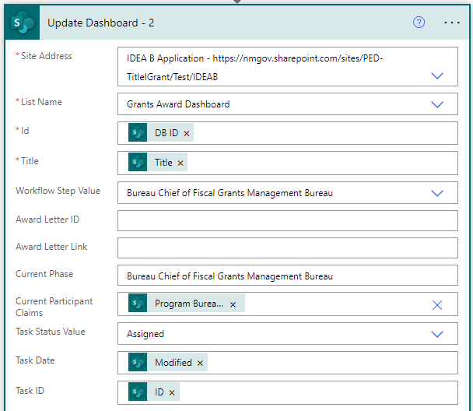

* + - 1. Create History Item – 2

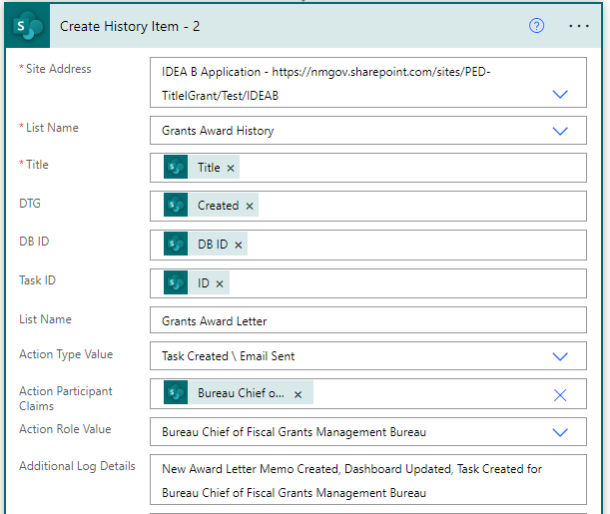

* + - 1. Stop Sharing Item - Grants Award Letter - Site Owner Keeps FC - 2

* + - 1. Grant Access - Requestor – 2

* + - 1. Grant Access - Director of Fiscal Grants Management Bureau

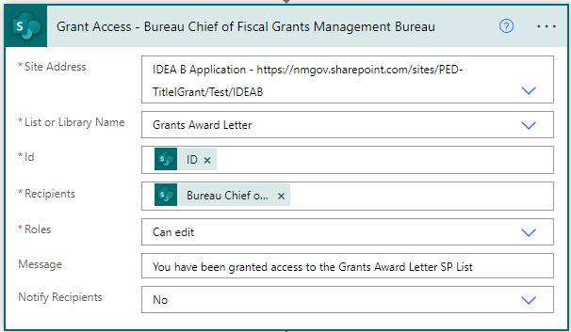

* + - 1. Terminate – 2

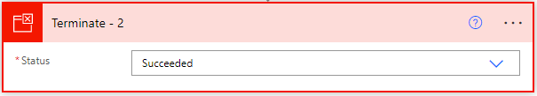

* + 1. **Dir of Administration Services Division**
       1. Create Task – 3

* + - 1. Send an Email – 3

* + - 1. Update Dashboard – 3

* + - 1. Create History Item – 3

* + - 1. Stop Sharing Item - Grants Award Letter - Site Owner Keeps FC – 3

* + - 1. Grant Access - Requestor – 3

* + - 1. Grant Access - Dir of Administrative Services Division

* + - 1. Terminate 3

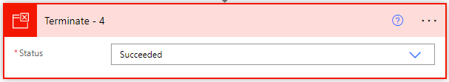

* + 1. **F&O Deputy Secretary**
       1. Create Task – 4

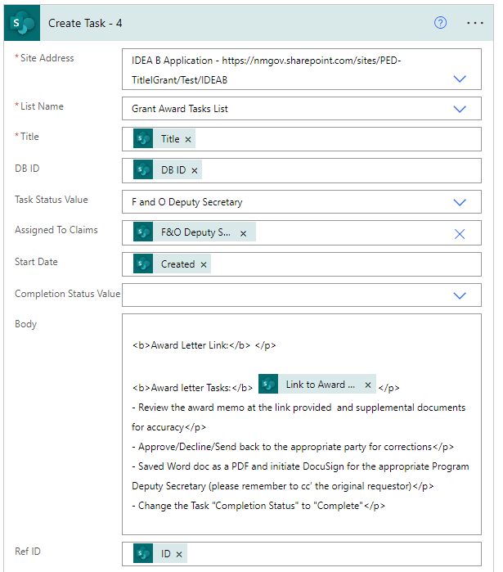

* + - 1. Send an Email – 4

* + - 1. Update Dashboards – 4

* + - 1. Create History Item – 4

* + - 1. Stop Sharing Item - Grants Award Letter - Site Owner Keeps FC - 4

* + - 1. Grant Access - Requestor - 4

* + - 1. Grant Access - F and O Deputy Secretary

* + - 1. Terminate – 5

* + 1. **Liaison**
       1. Create Task – 5

* + - 1. Send Email – 5

* + - 1. Update Dashboard – 5

* + - 1. Create History Item – 5

* + - 1. Stop Sharing Item - Grants Award Letter - Site Owner Keeps FC – 5

* + - 1. Grant Access - Requestor - 5

* + - 1. Terminate – 5

* + 1. **Case**
       1. Send an Email – 10

* + - 1. Update Dashboard – 10

* + - 1. Create a History Item – 10

* + - 1. Terminate – 10

* + 1. **Default**
       1. Send an Email – Default

* + - 1. Terminate – Default

* 1. Case Statements “If No”:
     1. **Terminate – Cancelled**

## Grants Award Letter Task Workflow:

* 1. Trigger:

* 1. Initialize Variable – Task Status:

* 1. Initialize Variable - Day of Week

dayOfWeek(utcNow())

* 1. Initialize Variable - Delay Count

* 1. Switch:

* 1. Monday:

* 1. Tuesday:

* 1. Wednesday:

* 1. Thursday:

* 1. Friday:

* 1. Saturday:

* 1. Sunday:

* 1. Default:

* 1. Condition:

* 1. Switch Statement:

* 1. Case Statement If Switch is “True”:
     1. **Program Director**
        1. Update Item 1

* + - 1. Create History Item 1

* + 1. **Director of Fiscal Grants Management Bureau**
       1. Update Item 2

* + - 1. Create History Item 2

* + 1. **Dir of Administration Services Division**
       1. Update Item 3

* + - 1. Create History Item 3

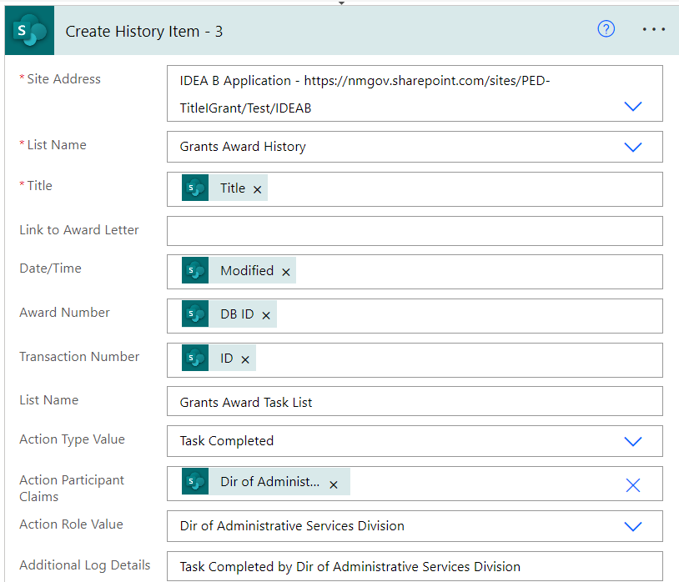

* + 1. **F&O Deputy Secretary**
       1. Update Item 4

* + - 1. Create History Item 4

* + 1. **Liaison**
       1. Update Item 5

* + - 1. Create History Item 5

* + - 1. Terminate

* + 1. **Default**
       1. Terminate 10

* 1. Case Statement “If No”:
     1. Switch – “Not Completed”

* + 1. Case – Assigned
       1. Create History Item – 10

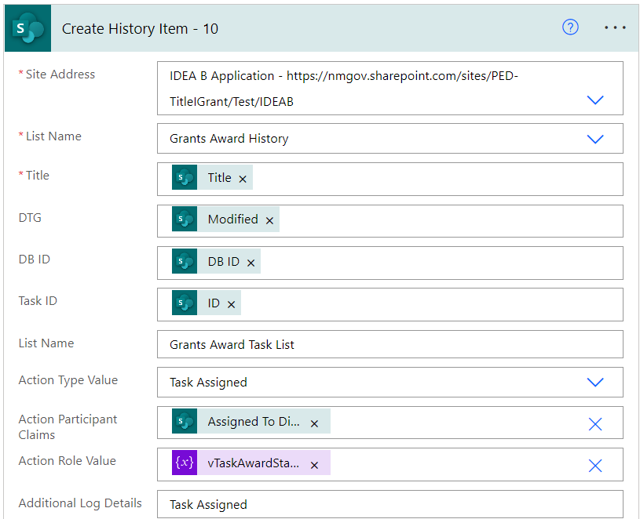

* + - 1. Delay – Assigned

* + - 1. Condition Assigned

* + - * 1. If Yes – Terminate 2

* + - * 1. If No – Send Email

* + - * 1. If No – Create History Item – 3 Day Reminder 1

* + 1. Case – Paused
       1. Create History Item – 11

* + - 1. Delay

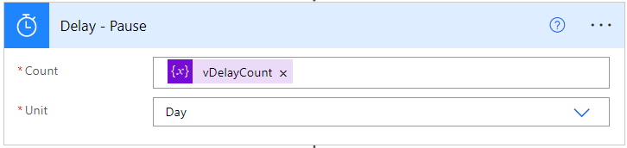

* + - 1. Condition – Paused

* + - * 1. If Yes – Terminate 3

* + - * 1. If No – Send Email – Paused

* + - * 1. If No – Create History Item – 3 Day Reminder 2

* + 1. Case – In progress
       1. Create History Item – In Progress

* + - 1. Delay - In Progress

* + - 1. Condition - In Progress

a). If Yes – Terminate 4

b). If No – Send Email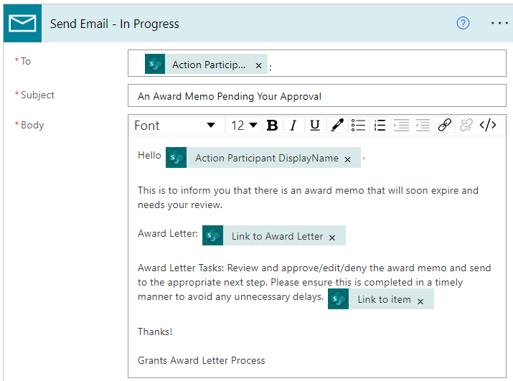

c). If No – Create History Item – 3 Day Reminder 3

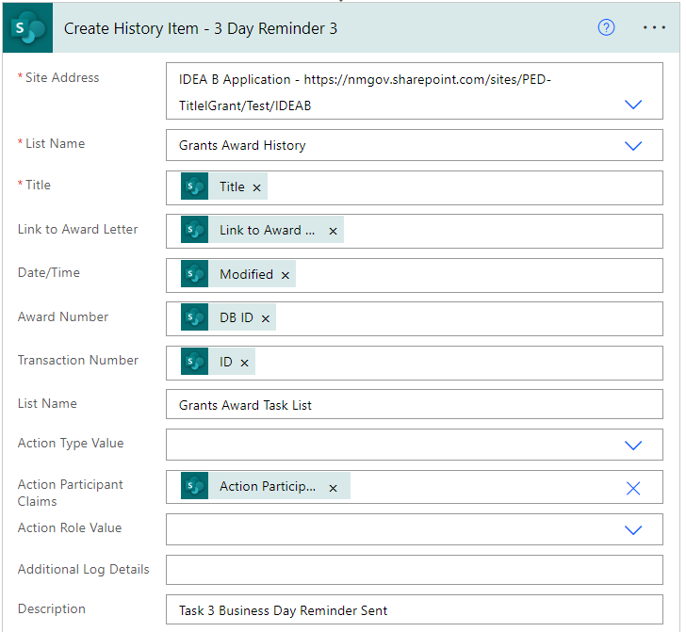

* + 1. Case – Cancelled
       1. Create History Item – 13

* + 1. Case – Default

* + 1. Terminate

## Appendix A – User Guide

## Appendix B – User Training